Open the "Foodmart_Data_Model.xlsx" worksheet that you saved on your desktop. This file was the finished product of your previous exercises. You should first complete all the other exercises and Quests before this one. Your Sheet1 should already have the Pivot Table you created from Exercise 4.1; if not, please redo the previous two assignments.

This is your starting point. It shows the Pivot Table you previously created.

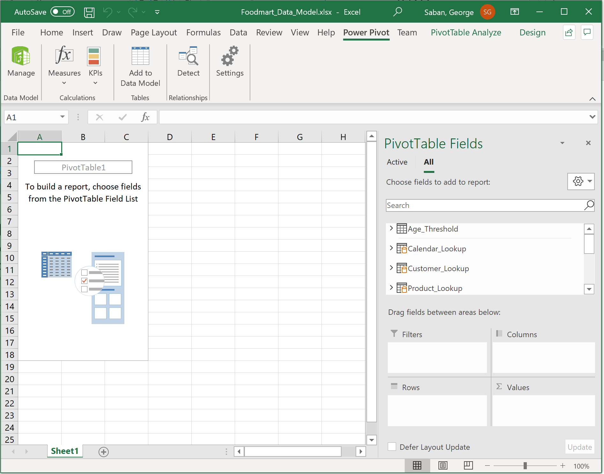

Click drop-down arrow of Measures, and select New Measures.

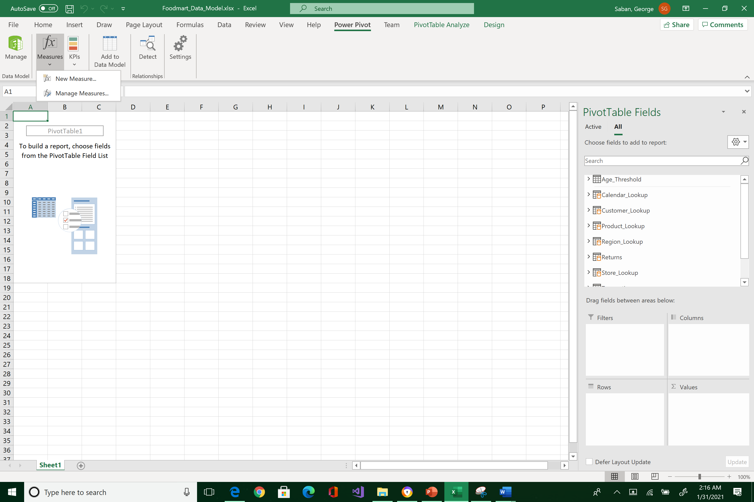



Type “Total Quantity” for Measure name.

Select Transactions table from the dropdown menu.

Give it a description of “Sum of quantity field from Transaction table”

In the formula cell type:



Click Check formula to verify that no syntax error was made. The green check mark should appear for approval.

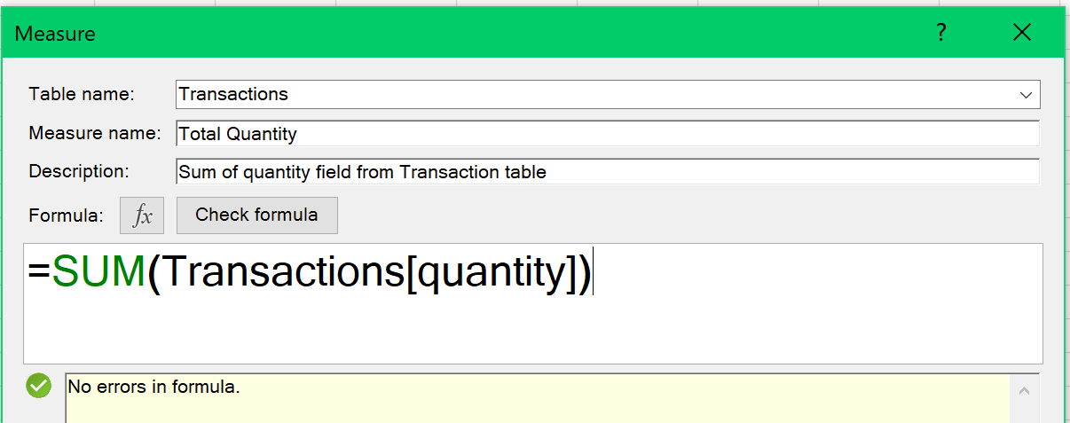



Format the output as: Number > Whole Number > check Use 1000 separator > OK

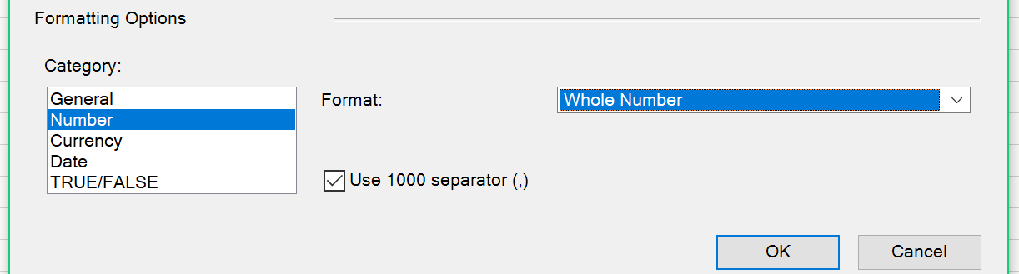



Go to the Pivot Table Fields pane and expand Transactions. Note the new measure Total Quantity.

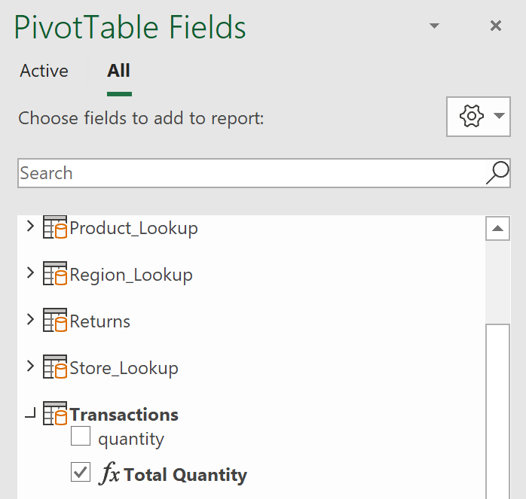



Observe also how the measure field Total Quantity is displayed inside the Values area.

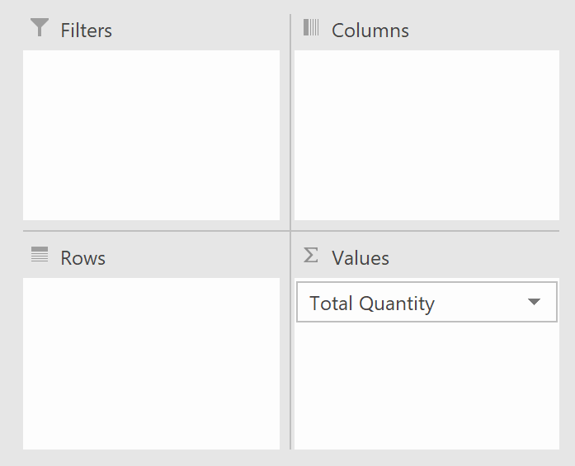



And it is also displayed in the Pivot Table area.

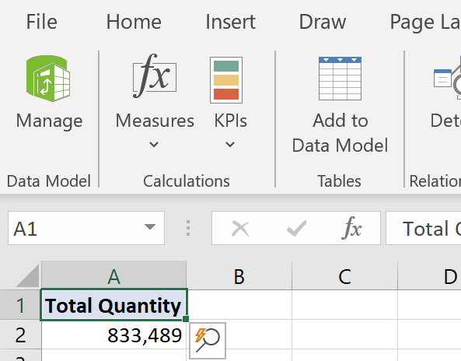



Go to the data model window by pressing Manage.

Select Transaction tab. Verify that the new measure is stored in the measure’s pane of Transactions’ table. Resize the column to see the full value. Save your work!

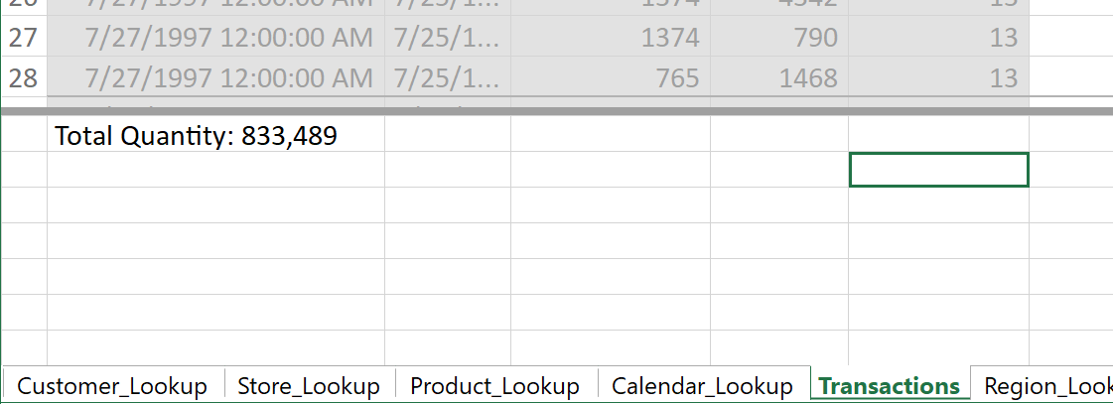



You’ve just learned the proper way of creating an explicit measure.

Reposition your screens so that the data model window is on top of the Excel window.

1. Take a snapshot using Window's Snipping Tool.
2. Make sure the system's date, your name, Transactions tab, and the four Total Quantity fields are included in the image.
3. Submit to Canvas in PNG format.

